Create and manage an environment
To create a new environment with Dataverse, use the following procedure:
- Sign in to the Power Platform admin center. The numbers in the image below correspond with the subsequent procedure steps.
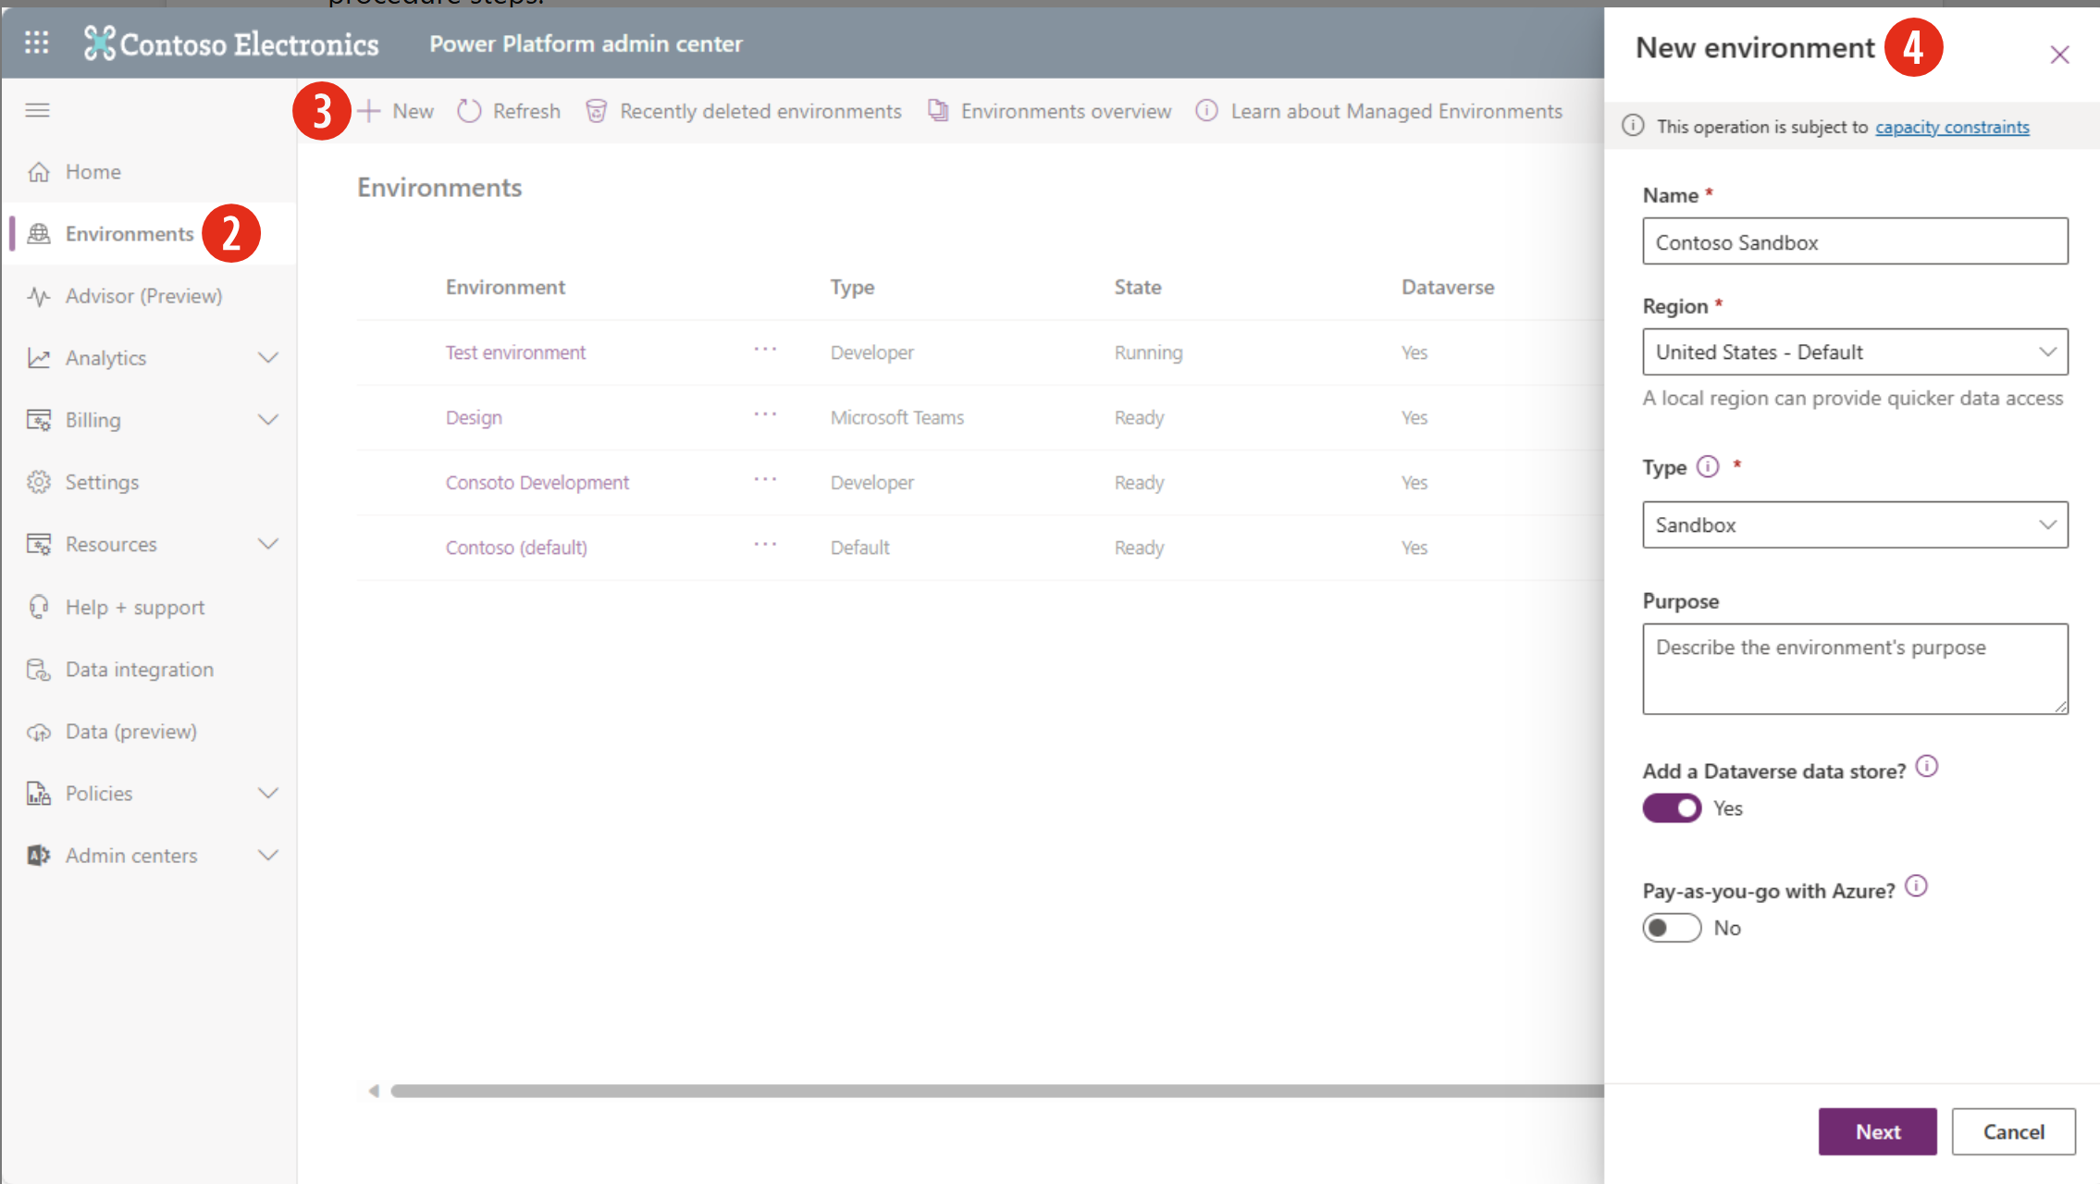
- Select Environments from the left-hand side rail.
- Select the New button from the top left side of the command bar.
- In the New Environment panel on the right side of your screen, you can name the new environment, select the region, choose the type, and describe the purpose. Notice the Add a Dataverse data store option. This option is only available for the sandbox or production environments, since trial and developer environments already include Dataverse.
By making this option Yes, you add the ability to use Dataverse tables built into this environment. Since this unit is about creating and managing environments in Dataverse, we want to ensure that we're adding a Dataverse data store. If you're creating a sandbox or production environment, toggle it to Yes.
The Pay-as-you-go with Azure toggle provides you with the option to pay for select Power Platform services such as Dataverse and Power Apps if you already have an Azure subscription. Unless you want to include this in your environment, leave it toggled to "No."
Once you've input the required options, you can initiate the creation of your new environment by selecting Next.
- The Add Dataverse panel appears next with any environment pending Dataverse data store creation. This tab completes the process of initiating a new environment with Dataverse.
  - The Language and Currency options default to the region selected in the previous tab, but you can select other options.
  - You must select a Security group but more on that in the next step.
  - You have options to create a custom URL, enable Dynamics 365 apps (depending on the type selected in the New environment tab, such as type Sandbox or Production), and to deploy sample apps with data.
You can select the back arrow at the top left of the panel to adjust your choice from the New environment tab. The following image shows the Add Dataverse tab if anything other than Developer is chosen.
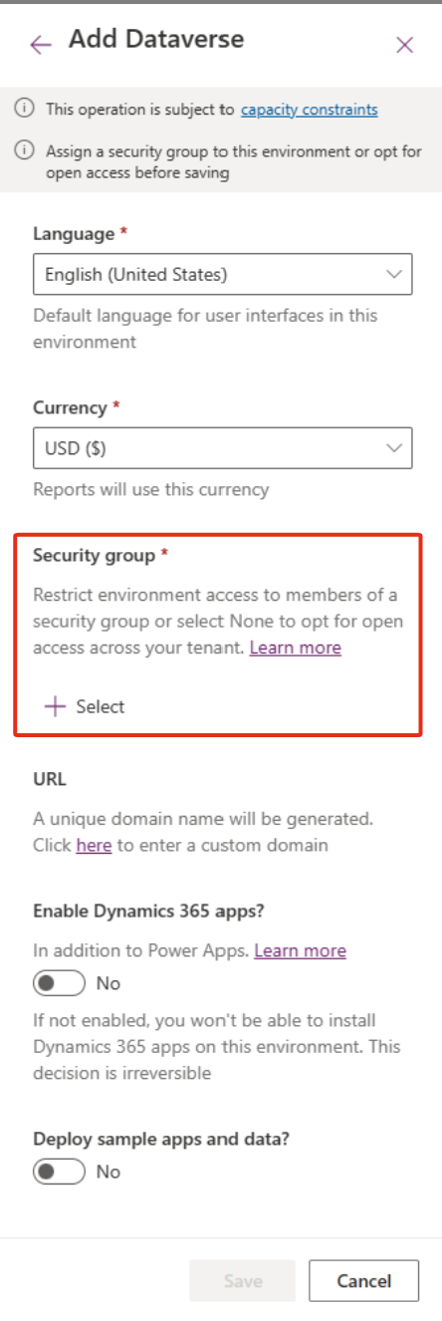
- Regarding the Security group option, you must select a Security group to create the environment. With a security group designated, you restrict access to the environment to members of that security group.
Note
The exception to the requirement to select a security group is the Developer environment, which includes Dataverse but simplifies the options to just language and currency.
Select the + Select button to choose a security group. Your options appear on the Edit security group panel, which appears next. You can search/scroll to find a particular group.
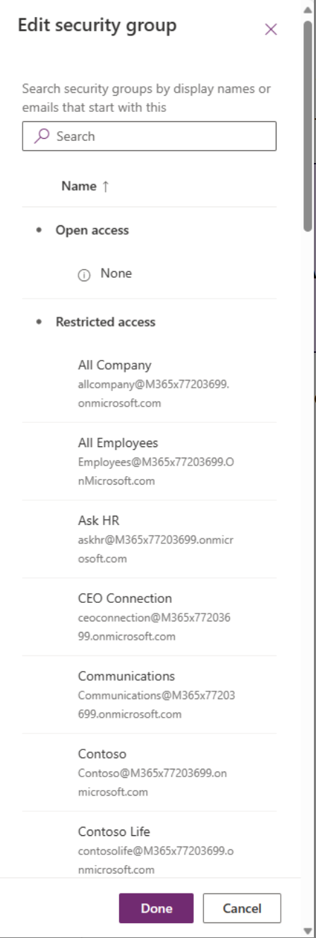
Notice that under "Open access" at the top, you can also opt for None, providing unrestricted access across your tenant (if you want all tenant users to be able to access this environment). Once you select a security group option, select Done to continue.
- With your security group selected (other than the environment type Developer), you can now select Save to create your new environment.
Tip
Remember, each environment requires 1GB of storage space from your Tenant and you can't create a new environment without it. If you don't have the space, you need to either purchase or create more space in your tenant. You can learn more about Dataverse storage capacity here, if required.
Congratulations, you just created a new environment including Dataverse!

